Native applications

Native applications live on the device and are all accessed through icons on the device's homescreen. These applications have to be installed from an application store (IOS. Android). They are developed for one type of mobile operating system and can take advantage of all of that devices features such as GPS, camera and they can also incorporate gestures(either standard or application defined). Native applications can also utilize the devices notification system.

Good :

* Access to all of the devices features
* Ability to work offline
* Ability to integrate with device notification system

Bad :

* Limitations can only be used with one mobile OS
* Costly as if you are developing the application for multiple devices then each new device will need its own unique version of the application

Web Applications

Web applications are not real applications, they really are smart websites that in many ways feel like native applications but are not implemented as such.

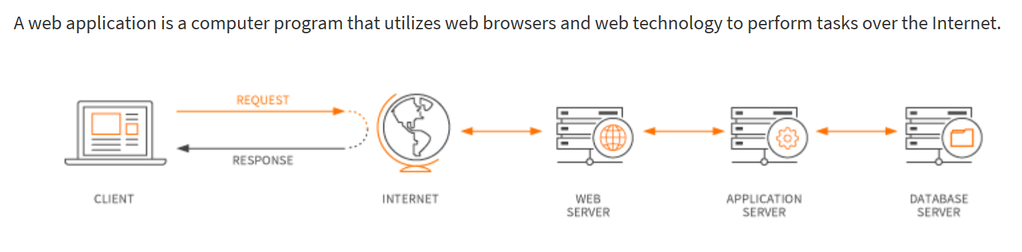

Web applications uses a combination of server side scripts (PHP, ASP) to handle the storage and retrieval of the information and client side scripts (Javascript and HTML) to present information to the users.

Web applications are usually coded in browser - supported language such as Javascript and HTML as these languages rely on the browser to render the program executable. Some applications are dynamic, requiring server side processing. Others are completely static with no processing required at the server.

Good :

* Will work all almost all devices
* Ability to access mobile hardware
* Cheaper to develop

Bad :

* Need to connect to the internet

Native :

<https://www.nngroup.com/articles/mobile-native-apps/>

Web app :

<https://www.maxcdn.com/one/visual-glossary/web-application/>